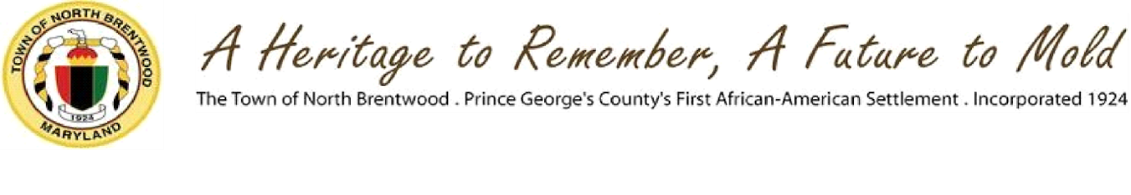

Scholarship Application
First Name* |  |  |  |  |  |  | Last Name*
Date of Birth* |  | Click here to enter a date. |  |  |  | Email Address*
Phone Number (Home)* |  |  |  |  |  |  |  | Phone Number (Cell)*
School Name *
School Address*
Scholarship Selection*
☐ | Vocational Education Scholarship
☐ | Academic Scholarship (Graduate)
☐ | Academic Scholarship (Undergraduate)
- General Eligibility*
Please describe your connection to the Town of North Brentwood, including people and time periods. You may reference documents such as census records, acquisition lists, and urban renewal records. Your response can be continued using a blank sheet. Number that sheet “1A and any succeeding sheets 2A, and so forth” to be identified as the continuation to this section.

- General Eligibility*
Please describe your past leadership experiences and commitment to community service. Your response can be continued using a blank sheet. Number that sheet “1B and any succeeding sheets 2B, and so forth” to be identified as the continuation to this section.

- Essay*
Please describe how North Brentwood positively impacted your life and how that impact helped you to decide to further your education. Number that sheet “1C and any succeeding sheets 2C, etc.” to be identified as the continuation to this section.

Scholarship Use*
- Vocational Education Scholarship*
Please describe your plan to attend a workshop, class, or similar program designed to create or enhance income-producing skills. Number that sheet “1D and any succeeding sheets 2D, etc.” to be identified as the continuation to this section.

- Financial Plan*
Please explain your plan for attendance, including other funding sources. For example, state whether you have completed the Free Application for Student Aid (FAFSA) or applied for other grants, scholarships. Number that sheet “1F and any succeeding sheets 2F, etc.” to be identified as the continuation to this section.

- Planned Activities*
Please describe the specific activities you plan to undertake to fulfill your commitment to restorative justice or community-building efforts. Number that sheet “1G and any succeeding sheets 2G, etc.” to be identified as the continuation to this section.
Scholarship Requirements / Commitments:
☐ | I plan to attend a full-time vocational program
☐ | My courses are for six months or longer
☐ | If funds are awarded for a program and I do not complete that program, I agree to refund the grant amount to the funder
☐ | I (or my relative) have/has 10 years of documented residency in the Town of North Brentwood
☐ | I am a citizen or permanent resident of the United States
☐ | I am a full-time student enrolled in a graduate program for the fall semester of the 2024-2025 academic year
☐ | I am a part-time student enrolled in a graduate program for the fall semester of the 2024-2025 academic year
☐ | I am a full-time student enrolled in an undergraduate program for the fall semester of the 2024-2025 academic year
☐ | I am a part-time student enrolled in an undergraduate program for the fall semester of the 2024-2025 academic year

Academic Scholarship Applicant must Include these Documents:
- Proof of Enrollment or Program Eligibility
- Transcript
- Two Letters of Recommendation
- One Page curriculum vitae (CV) or Resume

Scholarship applications become available March 14, 2025, and must be submitted by
April 30th, 2025.

APPLICATION SUBMISSION: Applications are due by April 30, 2025, by close of business.

- In-person – Submit your completed application, and support documents, to the Town Office at the North Brentwood Municipal Center, 4009 Wallace Road, North Brentwood, Maryland 20722. Town office hours: 9 am to 1 pm, on Monday, Tuesday and Thursday each week.
- By mail – Send your completed application and support documents to: Town of North Brentwood, P.O. BOX 196, North Brentwood, Maryland 20722.
- By email – Send your completed application and support documents to
jmorales@northbrentwood.com.

AWARD NOTIFICATION: Scholarship recipients will be notified in early July.

